SRS DOCUMENT
- ER Diagram
The ER diagram represents the logical structure of the Face Recognition–Based Attendance System. It shows entities such as Student, Faculty, Session, Attendance, and their relationships. This diagram helps in designing an efficient and well-structured database

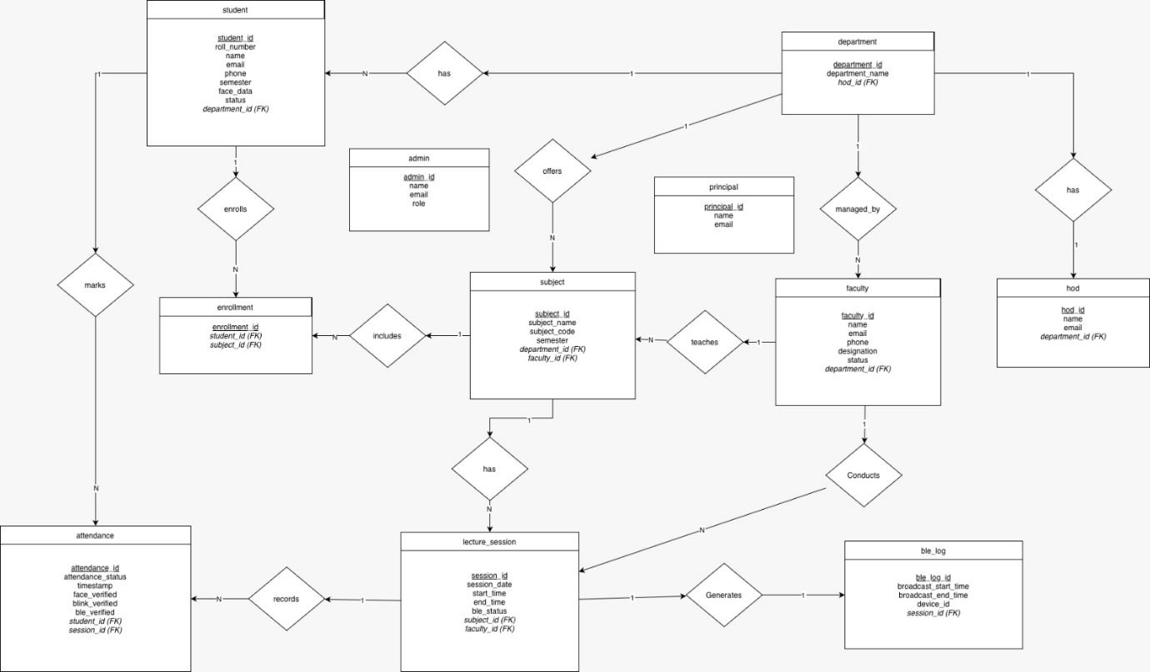

- Use case Diagram
The use case diagram describes the functional behavior of the system from the user’s perspective. It shows interactions between actors such as Student and Faculty with system functionalities. This diagram helps in identifying system requirements and user roles.

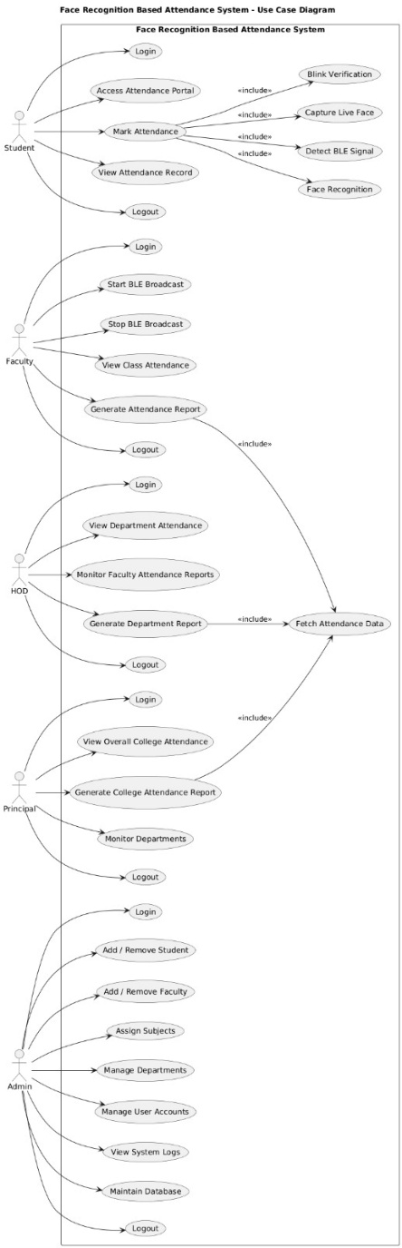

- Class Diagram
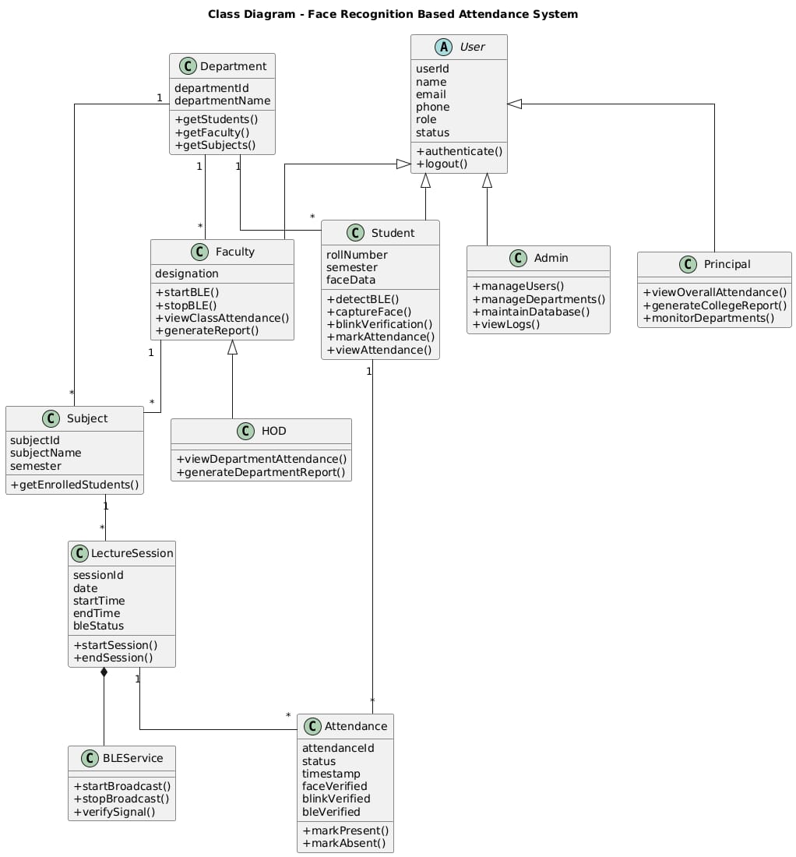
The class diagram provides a structural view of the system by illustrating classes, their attributes, methods, and relationships. It represents core components such as Student, Faculty, BLE Module, Face Recognition, and Attendance. This diagram helps in understanding the object-oriented design of the system.

- Sequence Diagram
The sequence diagram illustrates the time-ordered interaction between system components during attendance marking. It shows how BLE authorization, face recognition, and liveness detection occur step by step. This diagram helps in understanding the execution flow of the system.
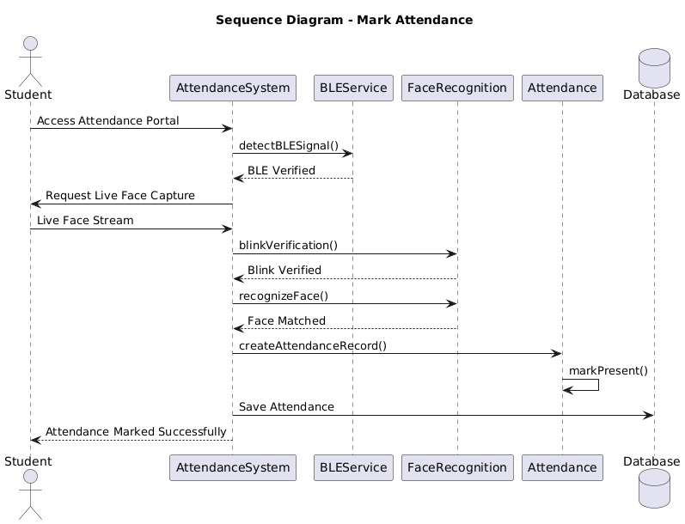

- Activity Diagram
The activity diagram represents the workflow of the attendance process. It shows the sequence of activities from BLE signal detection to face verification and attendance marking. This diagram helps in visualizing decision points and control flow in the system.


- Data Flow Diagram
A Data Flow Diagram (DFD) represents the flow of data within the Face Recognition–Based Attendance System. It shows how data such as BLE authorization signals and live facial inputs are processed to verify student presence. The DFD helps in understanding interactions between students, faculty, system modules, and the attendance database to ensure secure and accurate attendance marking.

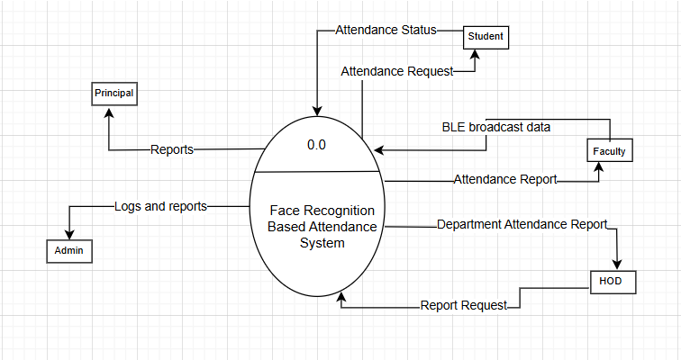

DFD Level 0

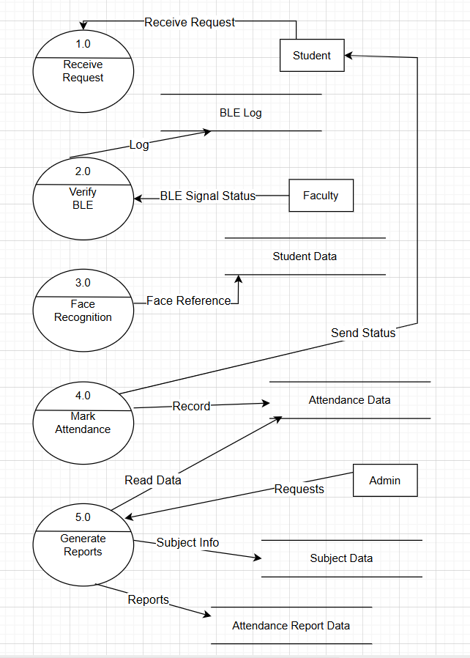

DFD Level 1

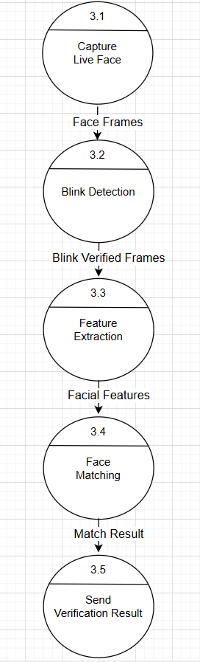

DFD Level 2

